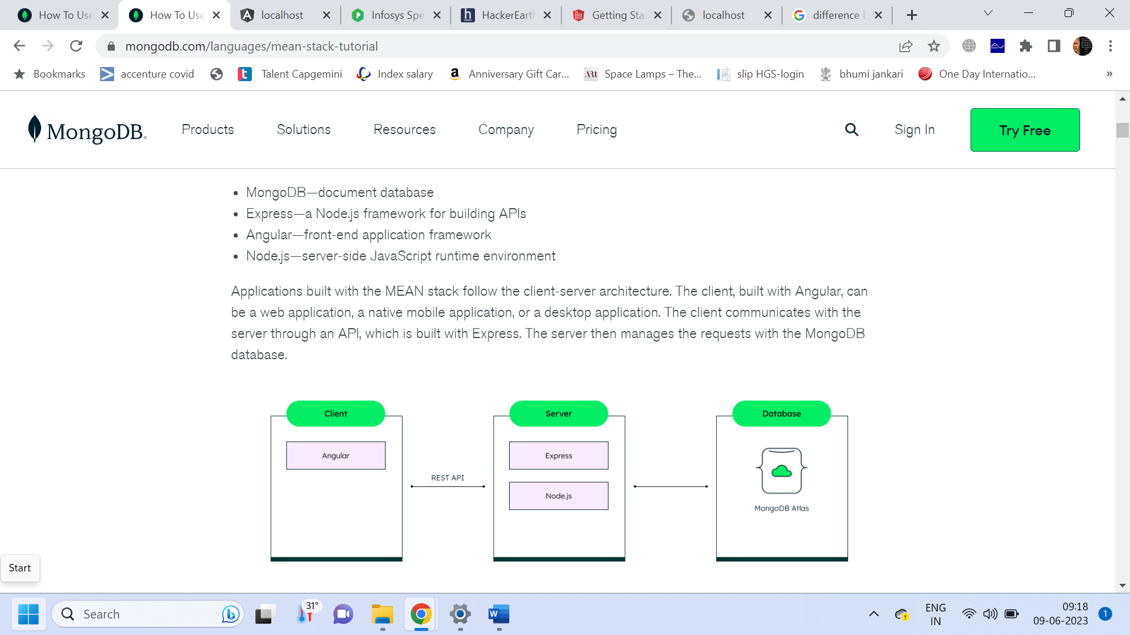

Building the server-side Node.js and Express application